**Simulation COMSOL Dynabeads**

For simulations of Helmholtz coils system the software Comsol 5.2a was used with an access on TU Dresden Taurus supercomputer cluster. The aim of the system is to see possible magnetic fields dependent on current intensity. The system we simulated consists of two pair coils systems each of which initiates magnetic field in one dimension. For simplicity of simulations we have shown two pairs system; specifications are given in the table 1.

Table 1. Coils specification

|  |  |  |
| --- | --- | --- |
|  | Medium | Smallest |
| Coils diameter | 70 mm | 56 mm |
| Turns per coil | 362 | 349 |
| Distance between 2 parallel coils | 41 mm | 28 mm |

|  |  |
| --- | --- |
| Magnetic permeability | mu_0=0,0000013 H/m |

Table 2. Other related parameters of the system

|  |  |
| --- | --- |
| Current intensity 1 | 1,2 A |
| Current intensity 2 | 0,89 A |

Figure 1. 2 pair coils system model

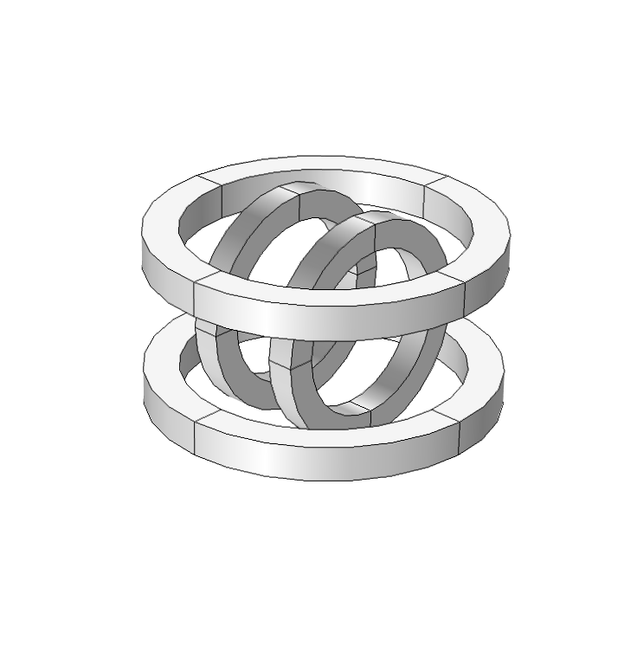

The system was placed to the air as a surrounding material and two current intensities (DC mode) were predefined before we started simulations. The reason of DC simulation was the stability of the numerical solutions and its convergence. The tetrahedral coarse mesh grid was imposed on the system with the maximum sample size of 5 mm.

Figure 2. Mesh imposed on the model

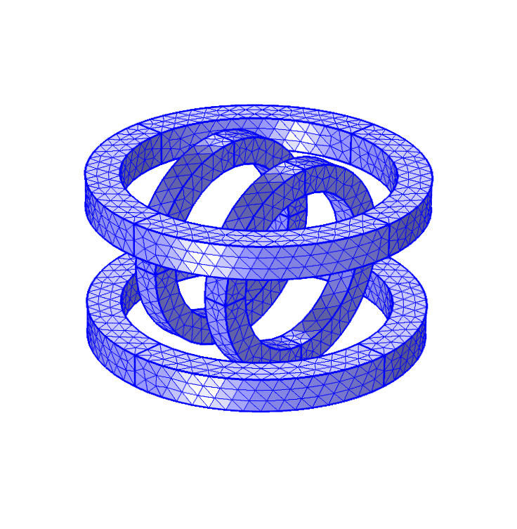

The solution method used was FGMRES. The resulted plot gives the magnetic flux profile and also the intensity pictures of magnetic field. We can determine the orientation of dynabeads particles in the center of the system and easily predict dynabeads further movements with the applied field.

Figure 3. 3D profile of magnetic fields and plane representations

